|  |
| --- |
| Alien Blast |
| 2D Shooter Game Document |
| Version 1.1 All work Copyright © 2015 by Cistronix Games. All rights reserved. Jason Huang (300818592) Oct.5th,2015 |
|  |



Table of Contents

Version History 3

Version 1.1: 3

Version 1.2 5

Version 1.3 5

Version 1.4 6

Version 1.5 6

Version 1.51 7

Version 1.6 7

Version 1.8 8

Version 1.9 8

Version 1.91 9

Version 1.92 9

Version 2.0 9

Game Document 10

Game Overview 10

Game Play Mechanics 10

Camera 10

Controls 10

Interface Sketch 10

Menu and Screen Descriptions 11

Game World 12

Levels 12

Game Progression 12

Characters 12

Enemies 12

Weapons 12

Items 13

Script 13

PlayerController 13

PlayerBullet 13

PlayerCollider 13

GameController 13

GameBackground 13

EnemyGun 13

EnemyController 13

EnemyBullet 13

PickUpSpawn 14

Scoring 14

Sound Index 14

Story Index 14

Art / Multimedia Index 14

Design Notes 15

Future Features 15

# Version History

Project Github Link: <https://github.com/Strifez/Alien-Blast-2D-Shooter>

## Version 1.1:

Created all the Folders and imported all the necessary files (pictures, audio etc).

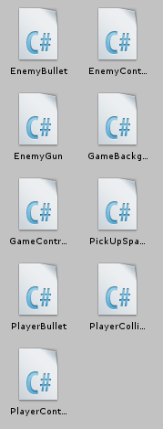_Scene- contains one scene called main

_Scripts – contain all the scripts

Animation – has the enemy and player movement animations

Audio – contains the sound effects and background music

Background – holds the background image

Materials – no materials were used in this project

Prefabs- contains the Enemy, Enemy Bullet, Player Bullet and the Pick Up Object

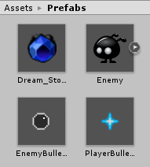 Sprites – contained all the sprites used in this game.

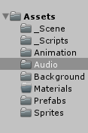

The Camera was not scrolling but the Background was scrolling to make it feel like the Player, and Enemy were moving along the x-axis (right to left). Player Movement Controls, Enemy Movement and Animation were implemented in this commit.

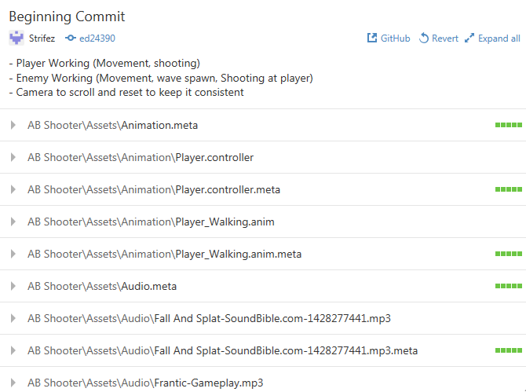

## Version 1.2

## Version 1.3

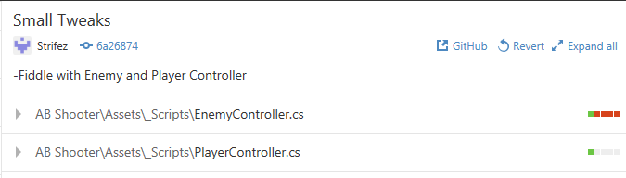



## Version 1.4

## Version 1.5

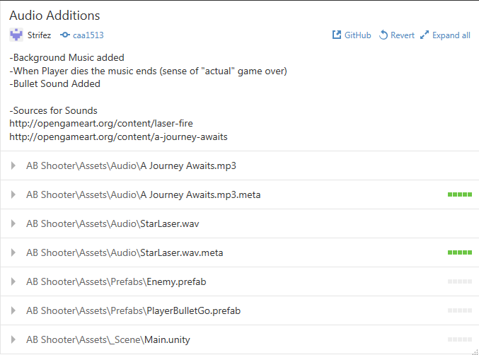

### Version 1.51

## Version 1.6

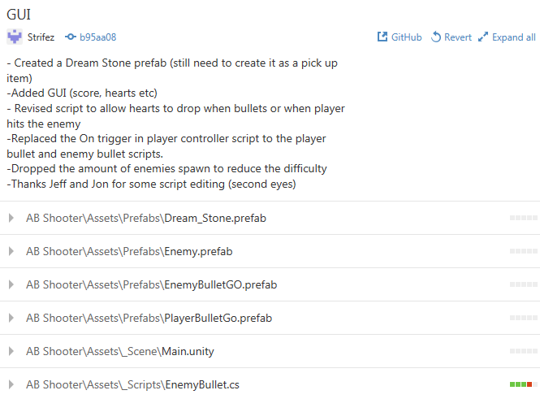

.

## Version 1.8

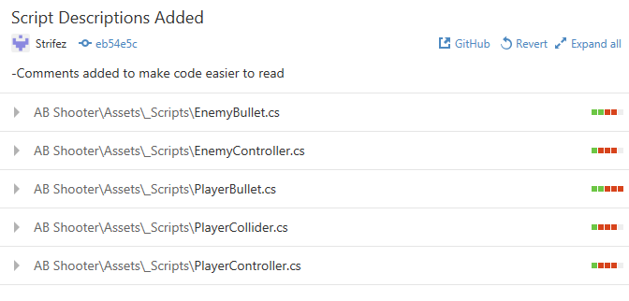

## Version 1.9

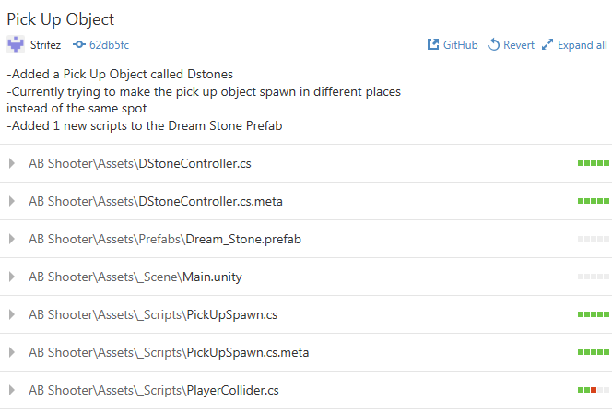

### Version 1.91

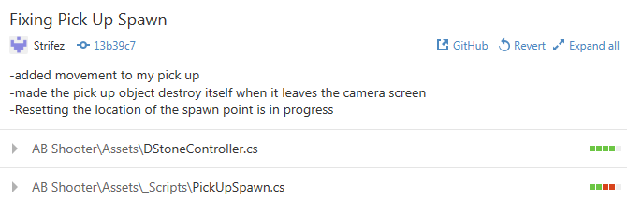

### Version 1.92

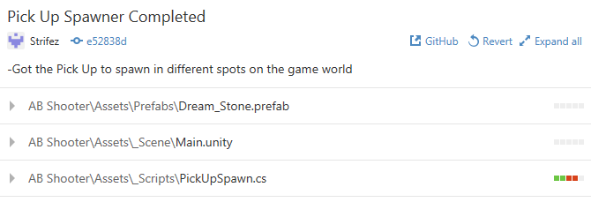

## Version 2.0

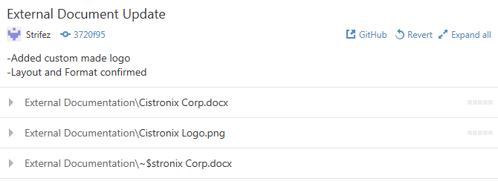

# Game Document

## Game Overview

The goal of the game is collect as much Dimension Stones as much as possible and survive as long as you can.

## Game Play Mechanics

The Enemy AI runs towards the player, and can fire bullets at the player (even when the enemy is behind the player.

## Camera

This is a 2D shooter game, the camera is locked and the background is moving to make the player feel as if the camera, player and enemies are moving. The Projection of the camera is Orthographic and is set on the bottom left of the background.

## Controls

The Player Movement is done by the Arrow keys (Left, Up, Down, Right) and Space Bar is used to fire bullets at the Enemy Blobs. Main input is the Keyboard

## Interface Sketch

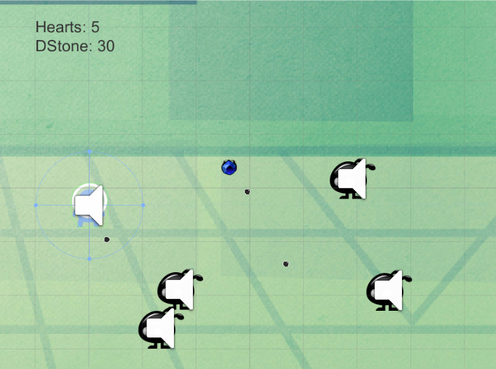The screen interface is found below. (Hearts = lives player has) (DStone = points)

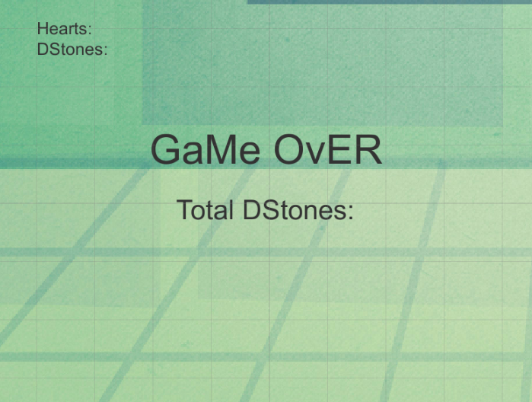

## Menu and Screen Descriptions

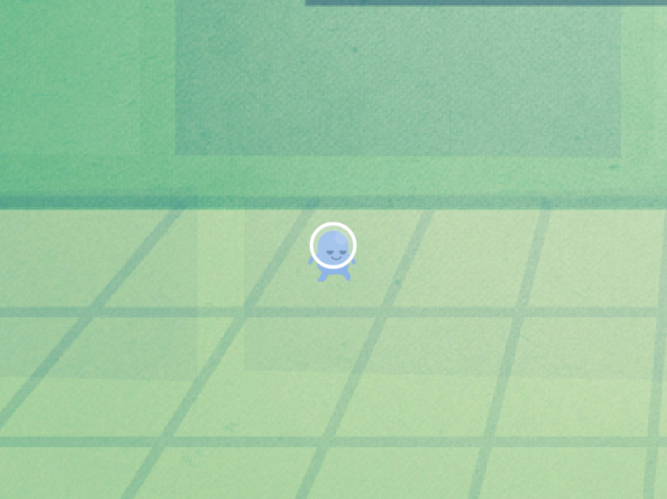This is the game screen (only one so far) screens will be added later on.

## Game World

The setting is on an unknown planet with a source of Dimension Stones, where Jub the main character needs to find a way to get back home.

## Levels

This game has only one level and that level is found to be fairly peaceful and “green”, Jub begins to exploring and finds that he is not the only one on the planet (more levels will be implemented in future DLC’s)

## Game Progression

The Game Progression is linear, the player travels along the “never ending” road to the source of Dimension Stones

## Characters

Jub is the player character and he is an alien looking for Dimension Stones. Upon a long journey, he landed nearby on an unknown planet due to low fuel; he finds that resources he needs to get off this planet called Dimension Stones. Jub is a species called Xeno and are known to be quite peaceful but when it comes to safety of other and survival they will do what is needed to maintain the peace.

## Enemies

The enemies are called Blobs. They are new creatures found on the unknown planet that Jub landed on. They are fairly slow, but they are always found in hordes of 5 or greater. Blobs are not powerful, firing mini bullets with incredible accuracy, at anything that is not their kind. The important thing about Blobs are when they are in hordes, the difficulty to deal with them is extremely hard because they take down the target in synchronization. (ex: shooting bullets in all directions)

## Weapons

The weapon Jub has to protect himself from the hordes of Blobs is called a Star Bullet.  This bullet is a special power Jub and his species can use. The energy comes from Jub, where he is constantly changing any source of energy in the air, storing it in his body and then converting it to a Star Bullet.

Blob uses the mini black bullets, it is unknown how they shoot with such accuracy and where it comes from but rumors say that it is actually a part of the Blobs body.

## Items

The items found in the planet is called Dimension Stones  (Source Maplestory) and it is what Jub wants to collect so he can fuel his ship and return to his home planet. Dimension Stones contain a lot of energy in its pure form but the ones found on the planet has already decay. As a result, Jub needs to collect a lot more in order for it to fuel his ship.

## Script

PlayerController – contains the boundaries of how far the player can move around and makes it so that Jub does not run off the screen. The script has the controls for movement and shooting

PlayerBullet – contains the instantiation of the bullet attached to the GameController called bulletspawn which is a child of the Player and allows the player to fire the bullet at enemies.

PlayerCollider- contains the GUI interfaces, the Gameover Texts, the triggers to add points, minus health and the audio sources. Finally it has an End Game function to end the game when the player loses all his lives.

GameController – contains the instantiation of the enemies

GameBackground – contains the Vector2 that moves the background to make it look like the objects in the game are moving.

EnemyGun- contains the script used for when the enemy fires the bullets at the Player by taking the player transform – from the bullet transform.

Source: Unity 2D Space Shooter Tutorial by Pixelelement Games.

<https://www.youtube.com/watch?v=iTHEXMF0hpc&index=6&list=PLRN2Qvxmju0Mf1GB1hXsT-x1GQJQ0pwE0>

EnemyController- contains the movement Vector2 to allow them to move towards the player and a boundary was added in order to destroy the enemies

EnemyBullet – contains the Awake function to initialize the variables before the game is open so the enemies will shot when the player spawns. The bullet transform is found then give it some physics and then the bullet is destroyed when it leaves the camera view.

Source: Unity 2D Space Shooter Tutorial by Pixelelment Games

PickUpSpawn- contains the code for the Dimension stone to spawn and trigged when the players touch it to get points.

Source: 2D Space Shooter by Unity

## Scoring

Pub killing an enemy gives 10 points

Pub collecting the Dstones gives 300 points

## Sound Index

Source: OpenGameArt

Background Music: A Journey Awaits by Lemon42

<http://opengameart.org/content/a-journey-awaits>

Enemy Death Sound: BSlimeDeath by qubodup

<http://opengameart.org/content/fly-swatter-squish-sound>

Bullet Noise: Star Laser by dklon

http://opengameart.org/content/laser-fire

## Story Index

Jub is the main character and upon a long journey, he landed nearby on an unknown planet, he finds that it contains adequate amounts of Dimension Stones needed to help him fuel and return to his home planet. However, along the way to the source of the stones he bumps into a horde of hostile blob like creature. Jub has no choice but to fight back, collect and survive.

## Art / Multimedia Index

Source: OpenGameArt

Player Image: Xeno Diversity by Arsonide

<http://opengameart.org/content/platformer-art-xeno-diversity>

Enemy Image: Land Monster Sprites by bevouliin

<http://opengameart.org/content/limbo-land-monster-sprites>

## Design Notes

The game was designed to have a more cartoon space feel to the game. The characters and even enemies are not the typical space alien theme. Cistronix Games wanted to make a game for all ages and we believe that with this cute, fast pace 2D shooter will be what everyone wants to play.

## Future Features

Will try to implement Menus and Upgrades such as more powerful shots.

New enemy units and Boss added and puzzles for the player to solve.